

**Software Requirements**

**Specification**

for

**An Automated System to Connect Users and Patients based on Service-Oriented Architecture**

**Version 1.0**

Prepared by

**Manas Trivedi**

**181CO231**

**Omanshu Mahawar**

**181CO237**

**NITK Surathkal, Karnataka**

**27th September 2020**

**Contents**

1.Introduction………………………………………………………………………………. 1

1.1Purpose………………………………………………………………………….. 1

1.2Scope……………………………………………………………………………. 1

1.3 Definitions, acronyms, and abbreviations…………………………………….... 1

1.4 References…………………………………………………………………….... 2

1.5 Overview……………………………………………………………………….. 2

2. Overall description………………………………………………………………………. 2

2.1 Product perspective…………………………………………………………….. 2

2.2 Product functions………………………………………………………………. 3

2.3 User characteristics…………………………………………………………….. 4

3. Specific requirements……………………………………………………………………. 4

3.1 External interface requirements………………………………………………... 4

3.1.1 User interfaces……………………………………………………….. 4

3.1.2 Hardware interfaces………………………………………………….. 5

3.1.3 Communications interfaces…………………………………………... 5

3.2 System features……….………………………………………………………... 5

3.2.1 Find Hospitals………………………………………………………... 5

3.2.1.1 Purpose……………………………………………………... 5

3.2.1.2 Stimulus/Response sequences…………………………….... 5

3.2.1.3 Functional requirements…..………………………………... 5

3.2.2 Patient Account……...……………………………………………….. 6

3.2.2.1 Purpose……………………………………………………... 6

3.2.2.2 Stimulus/Response sequences…………………………….... 6

3.2.2.3 Functional requirements…..………………………………... 6

3.2.3 Patient Appointments……………..………………………………….. 6

3.2.3.1 Purpose……………………………………………………... 6

3.2.3.2 Stimulus/Response sequences……………………………… 6

3.2.3.3 Functional requirements…..………………………………... 7

3.2.4 Hospital End Services...……………………………………………… 7

3.2.4.1 Purpose……………………………………………………... 7

3.2.4.2 Stimulus/Response sequences…………………………….... 7

3.2.4.3 Functional requirements…..………………………………... 8

3.3 Performance requirements……………………………………………………... 8

3.4 Safety requirements……………………………………………………………. 8

3.5 Security requirements………………………………………………………….. 8

3.6 Software system attributes……………………………………………………... 8

**1. Introduction**

**1.1 Purpose**

The purpose of this document is to describe the functional and nonfunctional requirements of the project, ‘An Automated System to Connect Patients and Hospitals based on Service-Oriented Architecture’ (ASCPH). It will describe the features, interfaces, and constraints of the system. This document is intended for the developers and the stakeholders of the system.

**1.2 Scope**

The software product to be developed is ASCPH, which shall provide three services. The first is to enable patients to find hospitals based on filters, such as treatment of specific diseases. The second is to allow patients to request appointments. The third is to enable hospitals to accept or reject appointment requests.

The system will be targeted towards patients residing in remote areas. Hence, the system will be designed to run on minimal bandwidth. Since time is a critical factor in situations where a hospital must be found and contacted immediately, the system will be designed to be intuitive and with low loading time, so that users can use the system quickly to access patient-related services.

**1.3 Definitions, acronyms, and abbreviations**

**1.3.1 Definitions**

|  |  |
| --- | --- |
| **Term** | **Definition** |
| Appointment | Arrangement to meet a doctor working at a hospital at a particular time |
| Hospital Executive | A person who handles the updation of hospital details and approval and rejection of appointments. |
| Patient | A person who uses ASCPH to access services such as finding a hospital and booking appointments for treatment of diseases. |
| Service | A self-contained unit of software that performs a specific task. |

**1.3.2 Acronyms and abbreviations**

|  |  |
| --- | --- |
| ASCPH | Automated System to Connect Users and Patients |
| HEx | Hospital Executive |
| ID | Identification |

**1.4 References**

[1] IEEE-830-1998 - IEEE Recommended Practice for Software Requirements Specification

**1.5 Overview**

The rest of this document is organized into two sections, the Overall Description chapter and the Specific Requirements chapter. The Overall Description chapter is to give an overview of the functionality of ASCPH, in an informal manner, and is intended primarily for the stakeholders. The Specific Requirements chapter is aimed towards the developers to provide the technical details of the functionality.

**2. Overall Description**

**2.1 Product perspective**

ASCPH is an independent product, and is totally self-contained. The proposition for its development arose in response to the media reports during the summer of 2020 which stated that people were finding it difficult to find hospitals with available resources. Travelling to multiple hospitals to find an available resource can cost lives, as time is a critical factor in such situations. Hence, a need was felt to develop an application which could be used by patients to find and locate hospitals with resources which they require, and book appointments with the same. The context diagram in Figure 1 illustrates the user roles and the services which are used for interacting with ASCPH.

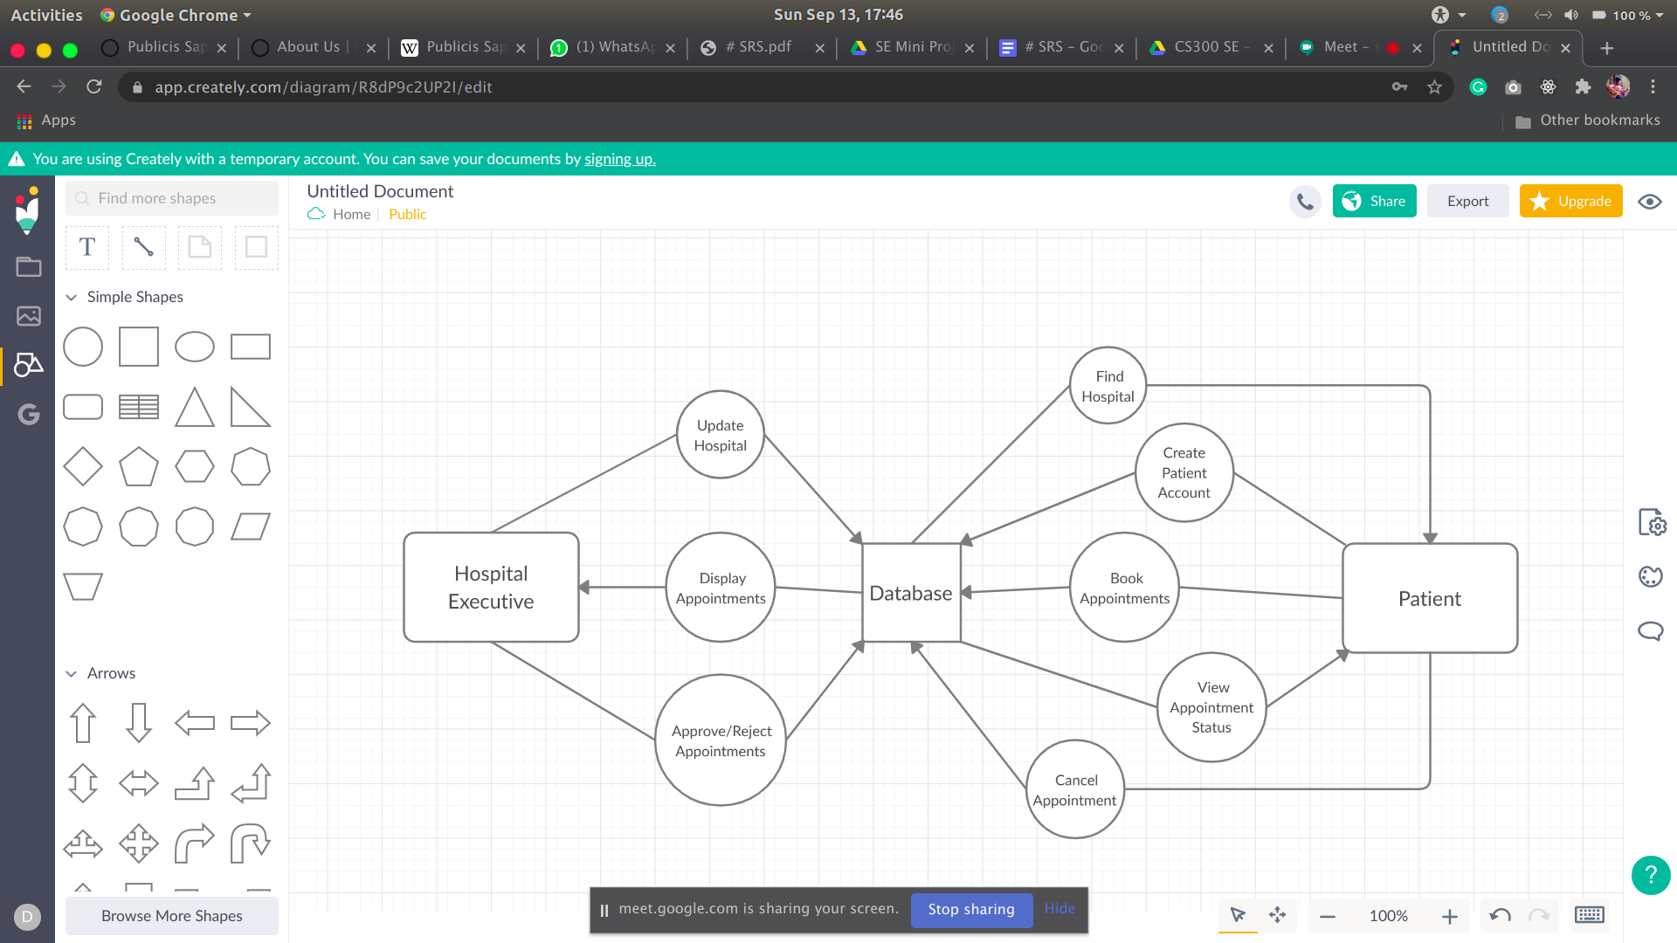

Fig. 1. ASCPH Context Diagram

**2.1.1 System interfaces**

The website for ASCPH must be platform independent, and hence must be compatible with all browsers on all operating systems, keeping in mind that the website may be used in critical situations, and hence compatibility issues must not arise for any user.

**2.1.2 Hardware interfaces**

In decreasing order of priority, the devices to be supported are: smartphones, laptops, personal computers, and tablets. This priority order has been decided keeping in mind the individuals living in remote areas, who have access to low-end devices like smartphones as opposed to high-end devices.

**2.1.3 Memory constraints**

ASCPH will be designed to run with very low memory requirements. Considering the average total primary memory required by background processes on a conventional device, a minimum of 512 MB of primary memory would be required.

**2.2 Product functions**

ASCPH has two active user roles, the patient and the Hospital Executive (HEx). The patient will be able to access two services, namely the ‘Find Hospitals’ service, the ‘Patient Account’ service, and the ‘Patient Appointment’ service. The HEx will be able to access three services which constitute the Hospital-end services. A summary of these services is provided in the following subsections.

**2.2.1 Find Hospitals**

This service will be used by a patient to find and locate hospitals. The user may select requirement(s) such as treatment of Covid-19, treatment of Asthma, etc. Based on the selection made, a list of nearest hospitals will be displayed to the patient. The patient may then view the details of each hospital present in the list. These details will include the location and the types of treatment available.

**2.2.2 Patient Account**

This service will be used by the patient to create an account, and later update the details of the account if required. Using this account, the patient will be permitted to book, view, and cancel appointments.

**2.2.3 Patient Appointment**

Upon selecting a hospital by using the Find Hospitals service, the patient can then book an appointment with the hospital for the treatment of one or more diseases, by specifying the type of treatment required, and the date of the appointment. The patient can also view the appointments he/she has requested, along with their statuses. The status of an appointment can be either ‘requested’, ‘approved’, ‘rejected’, or ‘cancelled’. Upon viewing the list of appointments, the patient shall be allowed to cancel an appointment. Appointments can be cancelled regardless of their status.

**2.2.4 Hospital-end services**

This collection of services will be used by the HEx for managing the hospital details, such as availability of treatment for specific diseases, type and number of available resources, etc., and appointments requested by patients with the hospital. The HEx shall be permitted to approve or reject appointments. If the HEx decides to approve an appointment, the HEx must also specify the time of the appointment.

It must be noted that the HEx won’t be permitted to create the hospital as an entity in the ASPCH - it would be done by the developers upon receiving a request from the hospital for the same.

**2.3 User characteristics**

|  |  |
| --- | --- |
| User Class | Characteristics |
| Patient | The patient using ASCPH must have an elementary understanding of navigating through generic websites. |
| HEx | The HEx must have expertise in entering and updating data, and will be required to go through the documentation intended for the HEx (which shall be created during the implementation phase). |

**3. Specific Requirements**

**3.1 External interface requirements**

**3.1.1 User interfaces**

UI-1: For laptop/PC users, the web application shall permit navigation and item selection using

the keyboard alone, in addition to using mouse and keyboard combinations.

UI-2: For smartphone users, the web application shall support hardware as well as virtual

keyboard for textual input, and touch input for item selection.

**3.1.2 Hardware interfaces**

In decreasing order of priority, the devices to be supported are: smartphones, laptops, personal computers, and tablets. This priority order has been decided keeping in mind the individuals living in remote areas, who have access to low-end devices like smartphones as opposed to high-end devices.

**3.1.4 Communications interfaces**

CI-1: The system shall send a notification to the user when their appointment has been

approved/rejected.

CI-2: The system shall send an email message to the user to confirm registration with the

system.

**3.2 System Features**

**3.2.1 Find Hospitals**

3.2.1.1 Purpose

This service will be used by a patient to find and locate hospitals. The user may select requirement(s) such as treatment of Covid-19, treatment of Asthma, etc. Based on the selection made, a list of nearest hospitals will be displayed to the patient. The patient may then view the details of each hospital present in the list. These details will include the location and the types of treatment available.

3.2.1.2 Stimulus/Response sequences

Stimulus: Patient requests the details of a particular hospital.

Response: System retrieves and displays the details of the particular hospital.

Stimulus: Patient requests a list of nearby hospitals with the optional application of filters.

Response: System displays a list of nearby hospitals in increasing order of distance from the

patient which satisfies the selected filters, if any.

3.2.1.3 Functional requirements

FH-1: The system shall allow the patient to search hospitals by name and view their details.

FH-2: The system shall allow the patient to get a list of nearby hospitals which satisfy certain

filters.

**3.2.2 Patient Account**

3.2.2.1 Purpose

This service will be used by the patient to create an account, and later update the details of the account if required. Using this account, the patient will be permitted to book, view, and cancel appointments.

3.2.2.2 Stimulus/Response sequences

Stimulus: Patient requests to create an account.

Response: System displays a form to allow the patient to enter Patient ID, name, and

password, which shall be used as inputs to create the account.

Stimulus: Patient requests to update account details.

Response: System provides a pre-populated form to allow the patient to update account

details.

3.2.2.3 Functional requirements

PA-1: The system shall allow the patient to create an account.

PA-2: The system shall allow the patient to update account details.

**3.2.3 Patient Appointment**

3.2.3.1 Purpose

Upon selecting a hospital by using the Find Hospitals service, the patient can then book an appointment with the hospital for the treatment of one or more diseases, by specifying the type of treatment required, and the date of the appointment. The patient can also view the appointments he/she has requested, along with their statuses. The status of an appointment can be either ‘requested’, ‘approved’, ‘rejected’, or ‘cancelled’. Upon viewing the list of appointments, the patient shall be allowed to cancel an appointment. Appointments can be cancelled regardless of their status.

3.2.3.2 Stimulus/Response sequences

Stimulus: Patient requests an appointment for a particular type of treatment on a particular

date.

Response: System stores the appointment request and displays a message stating that the

appointment has been requested.

Stimulus: Patient requests to view the status of the appointment requests.

Response: System displays the list of appointments requested by the patient along with their

status.

Stimulus: Patient requests to cancel an appointment.

Response: System cancels the appointment by updating the status of the appointment to

'cancelled', and displays a message stating that the appointment has been cancelled.

3.2.3.3 Functional requirements

AP-1: The system shall allow the patient to request an appointment on a certain day and for a

particular type of treatment.

AP-2: The system shall allow the patient to view the status of the appointment requests.

AP-3: The system shall allow the patient to cancel an appointment request.

**3.2.4 Hospital-end services**

3.2.4.1 Purpose

This collection of services will be used by the HEx for managing the hospital details, such as availability of treatment for specific diseases, type and number of available resources, etc., and appointments requested by patients with the hospital. The HEx shall be permitted to approve or reject appointments. If the HEx decides to approve an appointment, the HEx must also specify the time of the appointment.

It must be noted that the HEx won’t be permitted to create the hospital as an entity in the ASPCH - it would be done by the developers upon receiving a request from the hospital for the same.

3.2.4.2 Stimulus/Response sequences

Stimulus: HEx requests to update the details of the hospital.

Response: System provides a pre-populated form to allow the HEx to update the hospital

details.

Stimulus: HEx requests to view the appointment requests for the hospital.

Response: System displays the appointment requests for the hospital in increasing order of

dates.

Stimulus: HEx requests to approve an appointment request.

Response: An input dialog is displayed, where the HEx enters the appointment time. System

updates the status of the appointment to 'approved' and saves the appointment time.

Stimulus: HEx requests to reject an appointment request.

Response: System sets the status of the appointment request to 'rejected'.

3.2.4.3 Functional requirements

UH-1: The system shall allow the HEx to update the details of the hospital.

UH-2: The system shall allow the HEx to view the appointment requests for the hospital.

UH-3: The system shall allow the HEx to approve appointments and specify the appointment

time.

UH-4: The system shall allow the HEx to reject appointment requests.

**3.3 Performance requirements**

PE-1: Web pages must be fully downloadable in no more than 1 second on a 512 Kbps

connection.

PE-2: On each webpage, queries made to the database shall take no more than 1 second on a

512 Kbps connection.

**3.4 Safety requirements**

SA-1: The requirements PE-1 and PE-2 can be classified as safety requirements, due to their

time-critical nature.

**3.5 Security requirements**

SR-1: The user role ‘Patient’ must be required to create an account before booking

appointments.

SR-2: The user role ‘Patient’ will not be permitted to access the services meant for HEx in

section 3.2.4.

SR-3: The user role ‘HEx’ will not be permitted to create an account. The developer will

provide login credentials to the HEx upon obtaining a request for the same from the

corresponding hospital.

**3.6 Software system attributes**

SS-1: The system shall be easy to use for input preparation, operation, and interpretation of the

output.

SS-2: The system shall be easy for new or infrequent users to learn and to use the system.

SS-3: The system shall be easy to test and find defects.

SS-4: The system shall be easy to divide into different modules for testing.

SS-5: The system should be correct in terms of its functionality, and thereby must adhere to the

functional requirements specified in section 3.2.